**Result of lab 7:-**

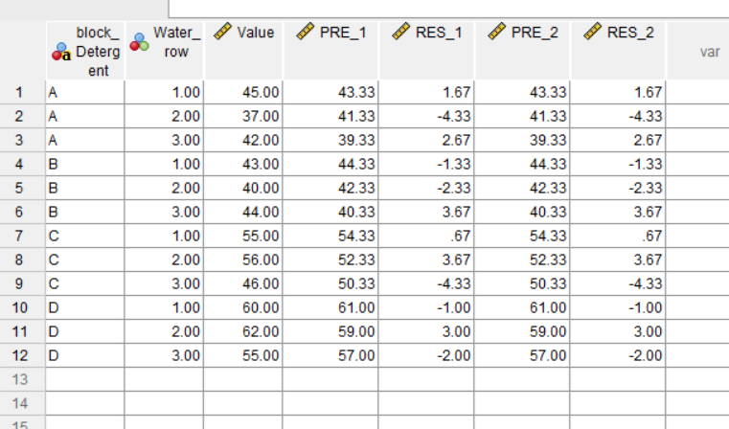

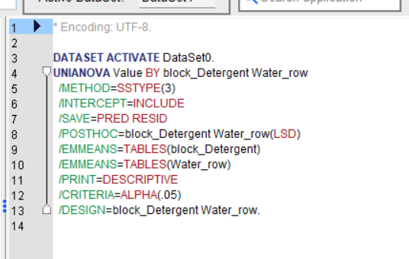

DATASET ACTIVATE DataSet0.

UNIANOVA Value BY block_Detergent Water_row

/METHOD=SSTYPE(3)

/INTERCEPT=INCLUDE

/SAVE=PRED RESID

/POSTHOC=block_Detergent Water_row(LSD)

/EMMEANS=TABLES(block_Detergent)

/EMMEANS=TABLES(Water_row)

/PRINT=DESCRIPTIVE

/CRITERIA=ALPHA(.05)

/DESIGN=block_Detergent Water_row.

**Univariate Analysis of Variance**

|  |  |  |
| --- | --- | --- |
| **Between-Subjects Factors** | | |
|  | | N |
| block_Detergent | A | 3 |
| B | 3 |
| C | 3 |
| D | 3 |
| Water_row | 1.00 | 4 |
| 2.00 | 4 |
| 3.00 | 4 |
|  |  |  |

|  |  |  |  |  |
| --- | --- | --- | --- | --- |
| **Descriptive Statistics** | | | | |
| Dependent Variable: Value | | | | |
| block_Detergent | Water_row | Mean | Std. Deviation | N |
| A | 1.00 | 45.0000 | . | 1 |
| 2.00 | 37.0000 | . | 1 |
| 3.00 | 42.0000 | . | 1 |
| Total | 41.3333 | 4.04145 | 3 |
| B | 1.00 | 43.0000 | . | 1 |
| 2.00 | 40.0000 | . | 1 |
| 3.00 | 44.0000 | . | 1 |
| Total | 42.3333 | 2.08167 | 3 |
| C | 1.00 | 55.0000 | . | 1 |
| 2.00 | 56.0000 | . | 1 |
| 3.00 | 46.0000 | . | 1 |
| Total | 52.3333 | 5.50757 | 3 |
| D | 1.00 | 60.0000 | . | 1 |
| 2.00 | 62.0000 | . | 1 |
| 3.00 | 55.0000 | . | 1 |
| Total | 59.0000 | 3.60555 | 3 |
| Total | 1.00 | 50.7500 | 8.09835 | 4 |
| 2.00 | 48.7500 | 12.14839 | 4 |
| 3.00 | 46.7500 | 5.73730 | 4 |
| Total | 48.7500 | 8.36796 | 12 |
|  |  |  |  |  |

|  |  |  |  |  |  |
| --- | --- | --- | --- | --- | --- |
| **Tests of Between-Subjects Effects** | | | | | |
| Dependent Variable: Value | | | | | |
| Source | Type III Sum of Squares | df | Mean Square | F | Sig. |
| Corrected Model | 674.250a | 5 | 134.850 | 8.428 | .011 |
| Intercept | 28518.750 | 1 | 28518.750 | 1782.422 | .000 |
| block_Detergent | 642.250 | 3 | 214.083 | 13.380 | .005 |
| Water_row | 32.000 | 2 | 16.000 | 1.000 | .422 |
| Error | 96.000 | 6 | 16.000 |  |  |
| Total | 29289.000 | 12 |  |  |  |
| Corrected Total | 770.250 | 11 |  |  |  |
| a. R Squared = .875 (Adjusted R Squared = .772) | | | | | |
| **Estimated Marginal Means**   |  |  |  |  |  | | --- | --- | --- | --- | --- | | **1. block_Detergent** | | | | | | Dependent Variable: Value | | | | | | block_Detergent | Mean | Std. Error | 95% Confidence Interval | | | Lower Bound | Upper Bound | | A | 41.333 | 2.309 | 35.682 | 46.984 | | B | 42.333 | 2.309 | 36.682 | 47.984 | | C | 52.333 | 2.309 | 46.682 | 57.984 | | D | 59.000 | 2.309 | 53.349 | 64.651 |  |  |  |  |  |  | | --- | --- | --- | --- | --- | | **2. Water_row** | | | | | | Dependent Variable: Value | | | | | | Water_row | Mean | Std. Error | 95% Confidence Interval | | | Lower Bound | Upper Bound | | 1.00 | 50.750 | 2.000 | 45.856 | 55.644 | | 2.00 | 48.750 | 2.000 | 43.856 | 53.644 | | 3.00 | 46.750 | 2.000 | 41.856 | 51.644 | | | | | | |
|  | | | | | |

**Post Hoc Tests**

**block_Detergent**

|  |  |  |  |  |  |  |
| --- | --- | --- | --- | --- | --- | --- |
| **Multiple Comparisons** | | | | | | |
| Dependent Variable: Value | | | | | | |
| LSD | | | | | | |
| (I) block_Detergent | (J) block_Detergent | Mean Difference (I-J) | Std. Error | Sig. | 95% Confidence Interval | |
| Lower Bound | Upper Bound |
| A | B | -1.0000 | 3.26599 | .770 | -8.9916 | 6.9916 |
| C | -11.0000* | 3.26599 | .015 | -18.9916 | -3.0084 |
| D | -17.6667* | 3.26599 | .002 | -25.6582 | -9.6751 |
| B | A | 1.0000 | 3.26599 | .770 | -6.9916 | 8.9916 |
| C | -10.0000* | 3.26599 | .022 | -17.9916 | -2.0084 |
| D | -16.6667* | 3.26599 | .002 | -24.6582 | -8.6751 |
| C | A | 11.0000* | 3.26599 | .015 | 3.0084 | 18.9916 |
| B | 10.0000* | 3.26599 | .022 | 2.0084 | 17.9916 |
| D | -6.6667 | 3.26599 | .087 | -14.6582 | 1.3249 |
| D | A | 17.6667* | 3.26599 | .002 | 9.6751 | 25.6582 |
| B | 16.6667* | 3.26599 | .002 | 8.6751 | 24.6582 |
| C | 6.6667 | 3.26599 | .087 | -1.3249 | 14.6582 |
| Based on observed means.  The error term is Mean Square(Error) = 16.000. | | | | | | |
| *. The mean difference is significant at the .05 level. | | | | | | |

**Homogeneous Subsets**

**Water_row**

|  |  |  |  |  |  |  |
| --- | --- | --- | --- | --- | --- | --- |
| **Multiple Comparisons** | | | | | | |
| Dependent Variable: Value | | | | | | |
| LSD | | | | | | |
| (I) Water_row | (J) Water_row | Mean Difference (I-J) | Std. Error | Sig. | 95% Confidence Interval | |
| Lower Bound | Upper Bound |
| 1.00 | 2.00 | 2.0000 | 2.82843 | .506 | -4.9209 | 8.9209 |
| 3.00 | 4.0000 | 2.82843 | .207 | -2.9209 | 10.9209 |
| 2.00 | 1.00 | -2.0000 | 2.82843 | .506 | -8.9209 | 4.9209 |
| 3.00 | 2.0000 | 2.82843 | .506 | -4.9209 | 8.9209 |
| 3.00 | 1.00 | -4.0000 | 2.82843 | .207 | -10.9209 | 2.9209 |
| 2.00 | -2.0000 | 2.82843 | .506 | -8.9209 | 4.9209 |
| Based on observed means.  The error term is Mean Square(Error) = 16.000. | | | | | | |